My Sunday meal prep recipes:
Best ever Hummus recipe, Perfect hard-boiled eggs, Slow Cooker Moroccan chicken + 3 basic meal dressings to have ready (optional)
Time for making those meals: 1h.30minuts ( + slow cooker time). All those meals will keep fresh 3-4 days in the fridge + dressings up to 4 weeks.
Best ever hummus recipe
Hummus contains protein, slow-release carbs and fibre. Tastes great and it curbs appetite. Hummus is a versatile food easy to use with eggs, vegetable crudites. Use it instead of mayonnaise and to make salad dressing with. The possibilities are endless…
Makes 4 servings ( feel free to double the ingredients)
- 1 can (15-ounce) chickpeas or (250 grams) cooked chickpeas
- Juice of ½ lemon
- 1 tablespoon (15 ml) well-stirred tahini
- 2 tablespoons (30 ml) extra-virgin olive oil, plus more for serving
- 4 tablespoon (60 ml) water for your chosen consistency
- 1 small garlic clove, minced (or a teaspoon of powder garlic)
- 1/2 teaspoon ground cumin (or to your taste)
- Salt to taste + ground paprika (optional)

Instructions
In the bowl of a food processor, combine the tahini and lemon juice and process for 1 minute, scrape the sides and bottom of the bowl then process for 30 seconds more.

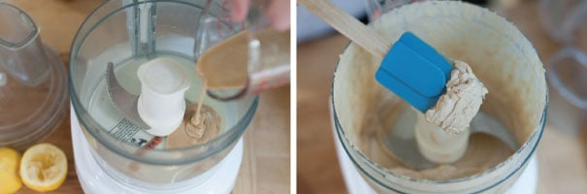

Add the olive oil, minced garlic, cumin, and a 1/2 teaspoon of salt to the whipped tahini and lemon juice. Process for 30 seconds, scrape the sides and bottom of the bowl then process another 30 seconds or until well blended. Open, drain, and rinse the chickpeas. Add half of the chickpeas to the food processor and process for 1 minute. Scrape sides and bottom of the bowl, then add remaining chickpeas and process until thick and quite smooth; 1 to 2 minutes.

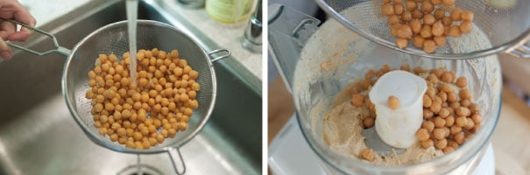

Most likely the hummus will be too thick or still have tiny bits of chickpea. To fix this, with the food processor turned on, slowly add 2 to 3 tablespoons of water until you reach the perfect consistency.
Taste for salt and adjust as needed. Serve hummus with a drizzle of olive oil and dash of paprika (optional). Store hummus in an airtight container and refrigerate up to one week.
NUTRITION PER SERVING: Serving Size 4 tbsp (60g)/ Calories 120

Hard-Boiled Eggs – so easy and versatile, but many of us forgot about the eggs

Instructions:

Place eggs in a large saucepan. Cover them with cool water by 2cm or 1 inch. Cover the pan with a lid and bring water to the boil over high heat; when the water is boiling, set the timer for the desired time. I like 6 minutes (min) hard-boiled eggs.
How long to boil eggs:  - soft-boiled eggs: 4 min  - slightly soft-boiled eggs: 5 min  - custardy yet firm soft-boiled eggs: 6 min  - creamy hard-boiled eggs: 7 min  - firm yet still creamy hard-boiled eggs: 8 min  - for very firm hard-boiled eggs: 9 min | 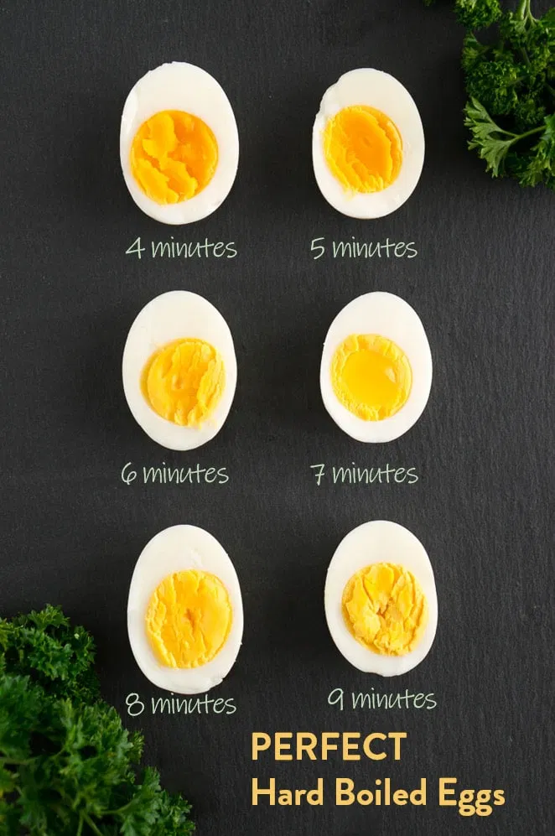

Slow Cooker Moroccan Chicken

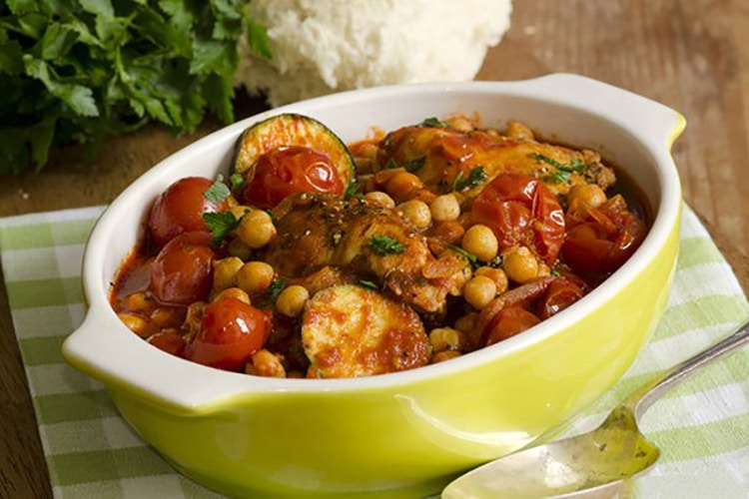
Serve 4: 444 calories per person
Ingredients
- 8-10 (3 pounds) bone-in chicken thighs (or combination of thighs and drumsticks), skin removed (optional)
- 1 onion, coarsely chopped
- 2 tablespoons tomato paste
- 20 cherry tomatoes
- 1 medium to large zucchini, sliced
- 2 carrots, sliced
- 2 teaspoons ground tumeric
- 1 teaspoon ground cumin
- 1 teaspoon ground coriander
- 1 teaspoon ground cinnamon
- 1 inch ginger root, peeled and finely minced or 1/2 teaspoon ginger powder
- 1/4 teaspoon cayenne pepper
- 1/2 teaspoon salt and freshly ground black pepper
- 1 cup chicken stock (or any other), low-sodium preferred
- 1 (15-ounce) can chickpeas, drained and rinsed (or can of beans)
- 1 bell pepper, stemmed, seeded, and sliced
- 1/2 cup dried, dried prunes or apricots or raisins
- 1/2 cup green olives (optional)
Serve: 4 cups cooked couscous or brown rice, cooked per pack instruction to serve
Instructions
Prep 10 minutes: Add chicken stock, spices, onions, peppers, olives, tomatoes, zucchini, tomato paste, and carrots to the slow cooker and stir. Add the chickpeas, dried fruit, chicken, and salt and pepper and stir again.
Cook in the slow cooker high setting for 3 to 4 hours or 6 to 8 hours (overnight) on a low setting, until the chicken is tender and the vegetables are cooked through. Enjoy.
3 Basic Meal Dressings
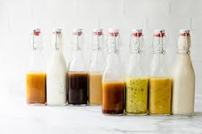

I love herbs & spices. According to science, we eat 15 % less if our food is adequately seasoned. I just want to show you how you can transform any salad, or any veg or meat dish, by just adding different dressings below.

Honey & mustard - French dressing 4 servings – total 500 calories

Ingredients: mix together 2 tsp wholegrain mustard with 2 tsp honey and the juice of 1 lemon in a small bowl. Gradually stir in 4 tbsp extra virgin olive oil (please note tablespoon of olive oil ~100 calories) and season with salt and pepper and granulated or minced garlic.

Asian Salad or Meat dressing 2 servings – total 250 calories
Ingredients: mix together 2 tbsp soy sauce, 2 tbsp sesame seeds, 2 tbsp groundnut oil or sesame oil, juice of 1 lime, 1/4 tsp of chilli flakes pinch of grated ginger and 1 x minced garlic (or powder) and 1 tsp honey to a small bowl and stir together.

Basic Italian Salad or Meat dressing 4 Serving - total 500 calories
Ingredients: mix together 4 tablespoons olive oil, 1 tablespoon white wine vinegar, 1 tablespoon chopped fresh parsley, 1 tablespoon fresh lemon juice, 1-2 garlic cloves minced or garlic powder, 1 teaspoon dried basil and a pinch of dried oregano.

