My favoured vitamin-D rich 3 meals for you to try
Go and buy all the ingredients this week and make it happen – enjoy x

(All- In- One) Salmon Traybake
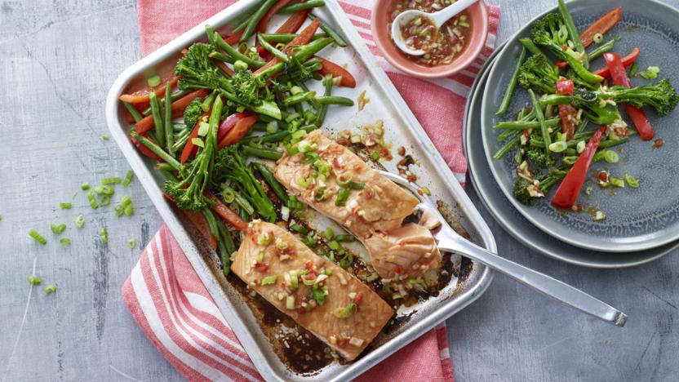

Serves: 2, Prep and cooking time 20-30 min

Ingredients
- 2 x 200g/7oz salmon fillets
- 100g/3½oz tendestem broccoli ( or regular), trimmed
- 100g/3½oz green beans, halved
- 1 small red pepper
- ½ lime, juice only
- 1 tbsp soy sauce
- ½ tsp caster sugar

For the dressing
- 1 small garlic clove, grated
- 1cm ½ inch piece fresh root ginger, peeled and grated
- 2 spring onions, white part finely chopped, green part thinly sliced
- 1 red finger chilli, very finely chopped
- ½ lime, juice only
- 1 tbsp soy sauce
- 2 tsp olive oil1 tsp sesame oil (optional
- ½ tsp caster sugar

Method
- Preheat the oven to 200 C/ 180 Fan 400/ Gas 5
- In a shallow bowl mix the lime juice, soy sauce and sugar together. Stir until the sugar dissolves. Place the salmon fillets into the bowl and coat with the mixture. Leave to stand, skin side up, for 10 minutes or so if have the time. Lightly grease a roasting tin with oil.
- Put the broccoli and green beans into a saucepan and cover with boiling water and cook for 1-2 minutes until tender but not cooked, then drain.
- Put the salmon fillets, skin side down at one end of the roasting tin. Tip the broccoli, beans and peppers into the other end of the roasting tin. Top with the red peppers and pour over the soy sauce mixture. Toss the vegetables to coat in the sauce. Loosely cover the vegetables and salmon with kitchen foil. Roast for 10- 2 minutes. Check not to overcook!
- Meanwhile, to make the dressing, mix the garlic, ginger, white part of the spring onions, chilli, lime juice, soy sauce, olive oil, sesame oil, and sugar together in a small jug.
- Spoon the dressing over the vegetables, sprinkle the green parts of the spring onion on top and serve. Serve with cooked brown rice (optional). x

Sardines & Eggs Salad with Tarragon Dressing

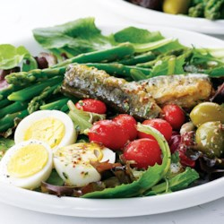
Tip: A bold, layered salad that showcases sardines and asparagus, this beautiful dish adds variety to your weekday dining. If you prefer tuna or salmon or maceral to sardines or have fish from the night before, go ahead and use that instead.

Ingredients for dressing
  - 2 tablespoons red-wine vinegar
  - 2 tablespoons extra-virgin olive oil
  - 1 teaspoon whole-grain mustard
  - ¼ teaspoon dried tarragon (or oregano)
  - Pinch of salt and pinch of freshly ground pepper
  - 1 clove garlic, crushed

  - ½ bunch asparagus, tough ends trimmed
  - 2 large hard-boiled eggs,
  - 5-ounce bag mixed salad greens, (about 5 cups)
  - 10 cherry tomatoes
  - 4-ounce (whole tin) can sardine, drained
  - 6 olives, (optional)

Method
Step 1
Whisk vinegar, oil, mustard, tarragon, salt and pepper in a small bowl. Add garlic and set aside.
Step 2
Bring 1 inch of water to a boil in a medium skillet. Add asparagus, stirring to submerge if necessary, and cook until bright green and crisp-tender, about 3 minutes. Drain and place under cold running water until cooled.
Step 3
Peel and slice eggs. Divide salad greens between 2 plates and top with the eggs, asparagus, tomatoes, sardines and olives (if using). Remove the garlic from the dressing, stir to combine and drizzle over the salads.
Tips
Make Ahead Tip: Hard-boil the eggs and refrigerate for up to 4 days.Tip: To hard-boil eggs: Place eggs in a single layer in a saucepan; cover with water. Bring to a simmer over medium-high heat. Reduce heat to low and cook at the barest simmer for 10 minutes. Remove from heat, pour out hot water and run a constant stream of cold water over the eggs until completely cooled.

Brunch-Style Portobello Mushrooms - below
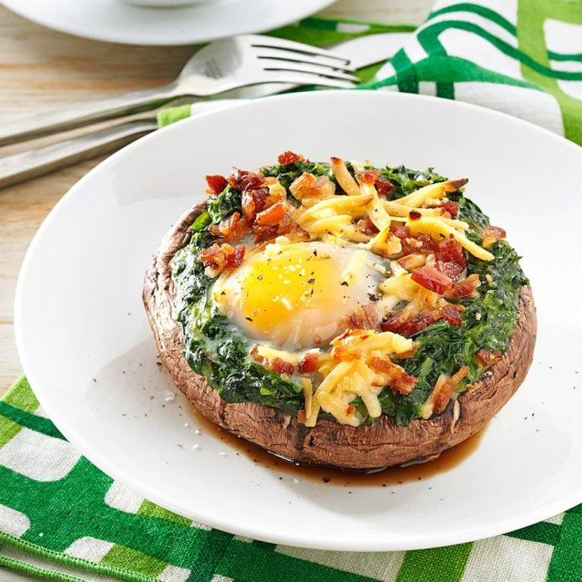

Ingredients
- 4 large portobello mushrooms, stems removed
- 2 packages (10 ounces each) frozen creamed spinach, thawed
- 4 large free-range eggs
- 1/4 cup shredded Gouda cheese
- 1/2 cup crumbled cooked bacon (optional)
- Salt and pepper, optional

Directions
- Place mushrooms stem side up, in an ungreased 15x10x1-in. baking pan. Spoon spinach onto mushrooms, building up the sides. Carefully crack an egg into the centre of each mushroom; sprinkle with cheese and bacon.
- Bake at 375° for 18-20 minutes or until eggs are set. Sprinkle with salt and pepper if desired.
Enjoy x

